SQL Server
- SQL SERVER is a relational database management system (RDBMS) developed by Microsoft.
- It is primarily designed and developed to compete with MySQL and Oracle database.
- SQL Server supports T-SQL (Transact-SQL).
- T-SQL is a Microsoft propriety Language known as Transact-SQL. It provides further capabilities of declaring variable, exception handling, stored procedure, etc.
- SQL Server Management Studio (SSMS) is the main interface tool for SQL Server, and it supports both 32-bit and 64-bit environments.

Version History SQL Server
- Microsoft and Sybase released version 1.0 in 1989.
- However, the partnership between these two ended in the early 1990s.
- Microsoft maintained ownership rights to the name SQL Server.
- Since the 1990s, subsequent versions of SQL Server have been released including SQL Server 2000, 2005, 2008, 2012, 2014, 2016, 2017, 2019, 2022 & 2024

SQL Server Editions
Following editions are available
SQL Server Enterprise: It is used in the high end, large scale and mission Critical business. It provides High-end security, Advanced Analytics, Machine Learning, etc.
SQL Server Standard: It is suitable for Mid-Tier Application and Data marts. It includes basic reporting and analytics.
SQL Server WEB: It is designed for a low total-cost-of-ownership option for Web hosters. It provides scalability, affordability, and manageability capabilities for small to large scale Web properties.
SQL Server Developer: It is similar to an enterprise edition for the non-production environment. It is mainly used for build, test, and demo.
SQL Server Express: It is for small scale applications and free to use.

Key Components and Services of SQL Server
Database Engine: This component handle storage, Rapid transaction Processing, and Securing Data.
SQL Server: This service starts, stops, pauses, and continues an instance of Microsoft SQL Server. Executable name is sqlservr.exe.
SQL Server Agent: It performs the role of Task Scheduler. It can be triggered by any event or as per demand. Executable name is sqlagent.exe.
SQL Server Browser: This listens to the incoming request and connects to the desired SQL server instance. Executable name is sqlbrowser.exe.
SQL Server Full-Text Search: This lets user running full-text queries against Character data in SQL Tables. Executable name is fdlauncher.exe.
SQL Server VSS Writer: This allows backup and restoration of data files when the SQL server is not running. Executable name is sqlwriter.exe.
SQL Server Analysis Services (SSAS): Provide Data analysis, Data mining and Machine Learning capabilities. SQL server is integrated with R and Python language for advanced analytics. Executable name is msmdsrv.exe.
SQL Server Reporting Services (SSRS): Provides reporting features and decision-making capabilities. It includes integration with Hadoop. Executable name is ReportingServicesService.exe
SQL Server Integration Services (SSIS): Provided Extract-Transform and Load capabilities of the different type of data from one source to another. It can be view as converting raw information into useful information. Executable name is MsDtsSrvr.exe

SQL Server Instances
- An instance is an installation of SQL Server.
- An instance is an exact copy of the same software.
- If we install 'n' times, then 'n' instances will be created.
- There are two types of instances in SQL Server a) Default b) Named.
- Only one default instance will be supported in one Server.
- Multiple named instances will be supported in one Server.
- Default instance will take the server name as Instance name.
- Default instance service name is MSSQLSERVER.
- 16 instances will be supported in 2000 version.
- 50 instances will be supported in 2005 and later versions.

Advantages of Instances
- To install different versions in one machine.
- To reduce cost.
- To maintain production, development, and test environments separately.
- To reduce temporary database problems.
- To separate security privileges.
- To maintain standby server.

SQL Server Architecture
- MS SQL Server is a client-server architecture.
- MS SQL Server process starts with the client application sending a request.
- The SQL Server accepts, processes and replies to the request with processed data.
Let's discuss in detail the entire architecture shown below:
As the below Diagram depicts there are three major components in SQL Server Architecture:
- Protocol Layer
- Relational Engine
- Storage Engine
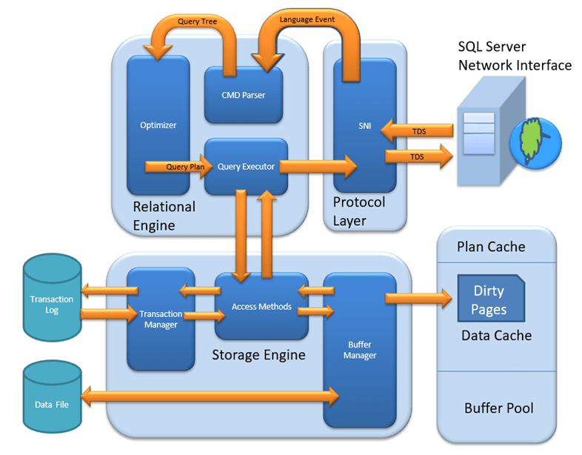SQL Server Architecture Diagram

Following is the process which a SQL Query goes through.
- The SQL query is fired at the application end. From there it is converted into TDS (Tabular Data Stream) Packets using ODBC or OLEDB or SNAC (SQL Native Client) or SNI (SQL Server Network Interface). These are data access protocols which are used to access all types of data and grind them into TDS packets to be encapsulated within network packets to be travelled through network protocols from one endpoint to other.
- Once TDS packets reach the server endpoint, the SNI decapsulates those packets into SQL commands.
- The commands are passed through Query Parser or Command Parser and it checks the query for any Syntactical (Syntax) or Semantical (Logical) errors and if any error occurs it returns the error to the N/W protocol layer.
- If it passes through the command parser, the next step is to generate a query plan. The query optimizer selects a cost-effective plan provided to it using Query Tree (It uses certain algorithms to generate different query plans and presents it to the Query Optimizer.
- Query optimizer then selects a cost-effective plan and presents the query to Query Executor. To execute a plan Query Executor needs data as well. So it passes the request to the Access Methods which is a collection of codes which provides an interface to retrieve data and present it to Query Executor after valid conversion using OLEDB. It itself does not do this work, rather it asks the buffer manager for the data.
- If the data is there in the Buffer, Access methods fetch those data pages and pass them to the query executor to execute the query. If the query plan is already in the Plan cache the executor uses that plan.
- The work of access method is to check if the query is select or non-select (DML). If the query is non-select the access methods contact Transaction Manager. Transaction Manager has two components,
  - Log Manager
Logs the events that will be modifying the data into Log Buffer in Buffer Pool.
  - Lock Manager
Assigns a lock on that transaction to provide data consistency and isolation.
- Transaction Manager generates a Log Sequential Number(LSN) for that transaction and records the events that will be modifying the data in Log Buffer and the Transaction will make changes in the buffer cache using only locking mechanism to be isolated from any other transaction who wants to modify the same data. Changes are not directly made to the data pages on the disk.

Installation Steps
Step 1 − Download the Evaluation Edition from http://www.microsoft.com/download/en/details.aspx?id=29066
Once the software is downloaded, the following files will be available based on your download (32 or 64 bit) option.
ENU\x86\SQLFULL_x86_ENU_Core.box
ENU\x86\SQLFULL_x86_ENU_Install.exe
ENU\x86\SQLFULL_x86_ENU_Lang.box
OR
ENU\x86\SQLFULL_x64_ENU_Core.box
ENU\x86\SQLFULL_x64_ENU_Install.exe
ENU\x86\SQLFULL_x64_ENU_Lang.box
Note − X86 (32 bit) and X64 (64 bit)
Step 2 − Double-click the “SQLFULL_x86_ENU_Install.exe” or “SQLFULL_x64_ENU_Install.exe”, it will extract the required files for installation in the“SQLFULL_x86_ENU” or “SQLFULL_x86_ENU” folder respectively.
Step 3 − Click the “SQLFULL_x86_ENU” or “SQLFULL_x64_ENU_Install.exe” folder and double-click “SETUP” application.
For understanding, here we have used SQLFULL_x64_ENU_Install.exe software.
Step 4 − Once we click on 'setup' application, the following screen will open.
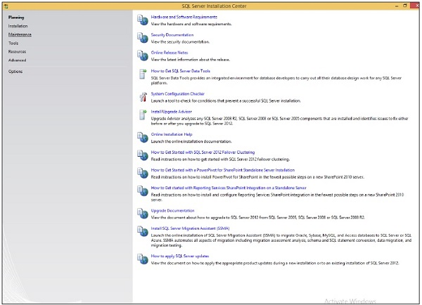
Step 5 − Click Installation which is on the left side of the above screen.
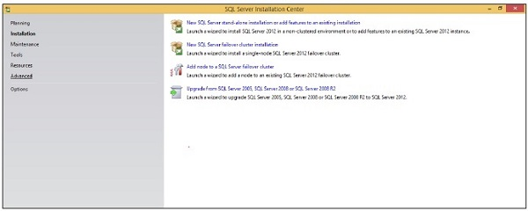
Step 6 − Click the first option of the right side seen on the above screen. The following screen will open.
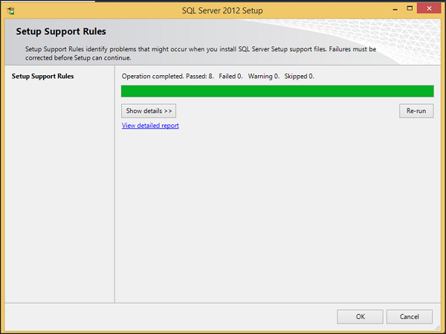
Step 7 − Click OK and the following screen pops up.
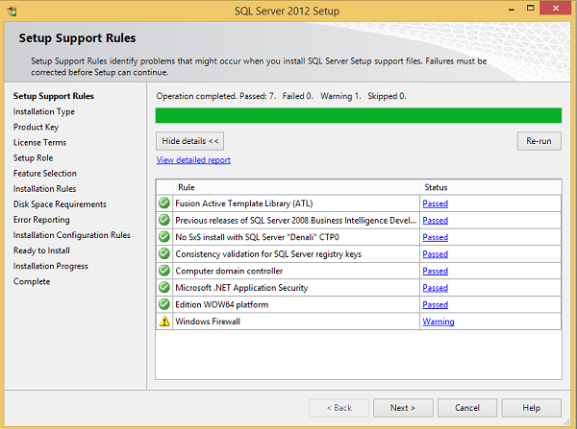
Step 8 − Click Next to get the following screen.
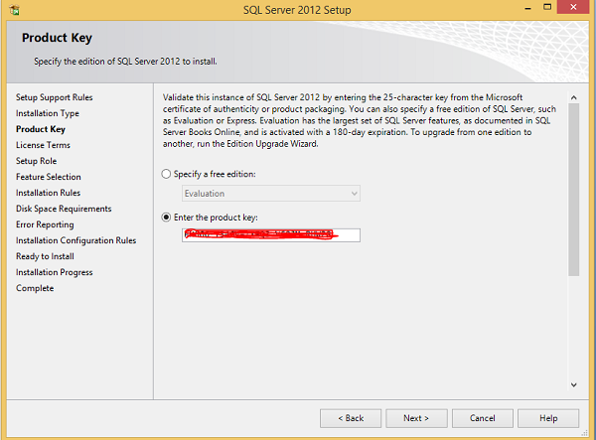
Step 9 − Make sure to check the product key selection and click Next.
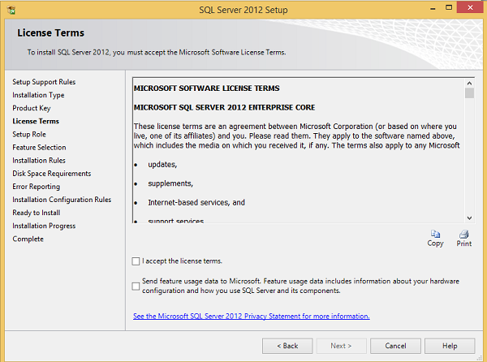
Step 10 − Select the checkbox to accept the license option and click Next.
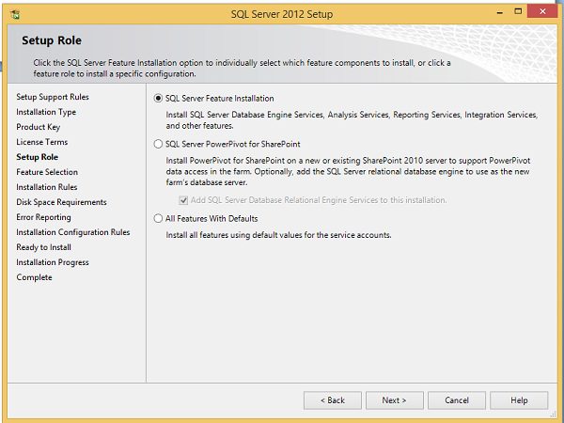
Step 11 − Select SQL Server feature installation option and click Next.
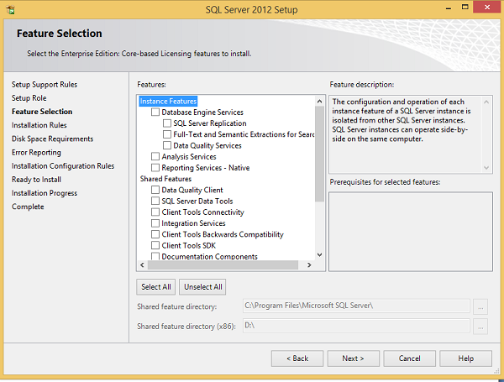
Step 12 − Select Database engine services checkbox and click Next.
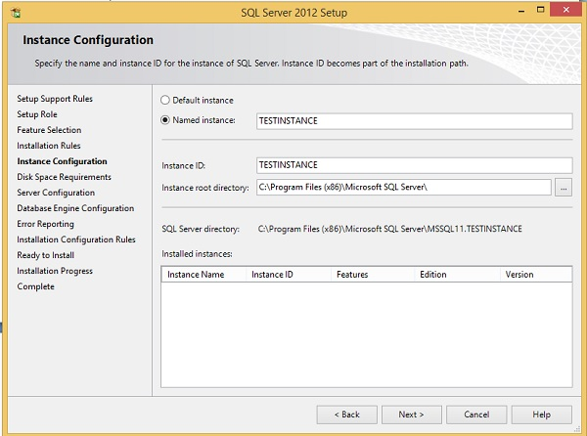
Step 13 − Enter the named instance (here I used TestInstance) and click Next.
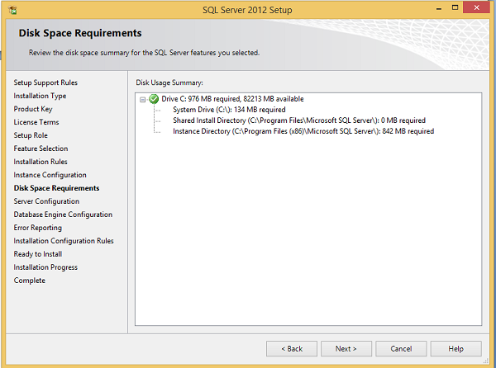
Step 14 − Click Next on the above screen and the following screen appears.
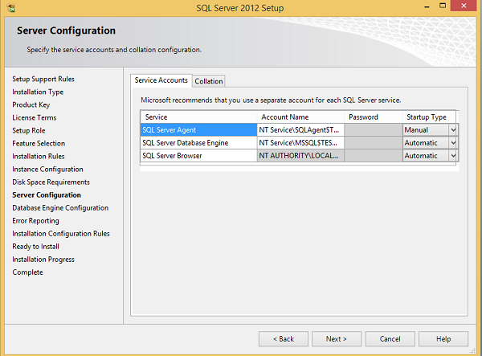
Step 15 − Select service account names and start-up types for the above listed services and click Collation.
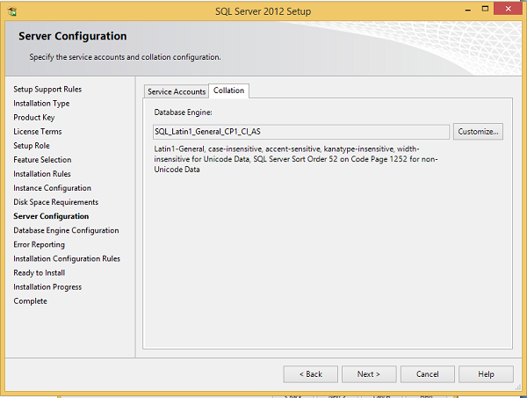
Step 16 − Make sure the correct collation selection is checked and click Next.
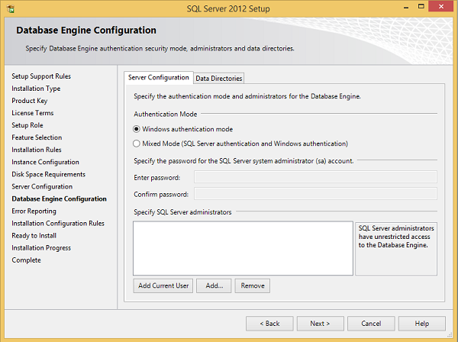
Step 17 − Make sure authentication mode selection and administrators are checked and click Data Directories.
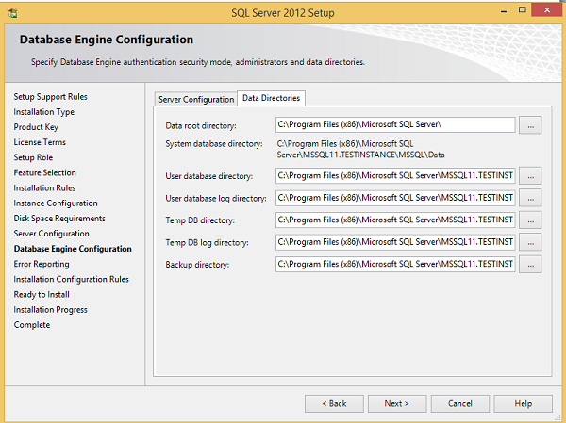
Step 18 − Make sure to select the above directory locations and click Next. The following screen appears.
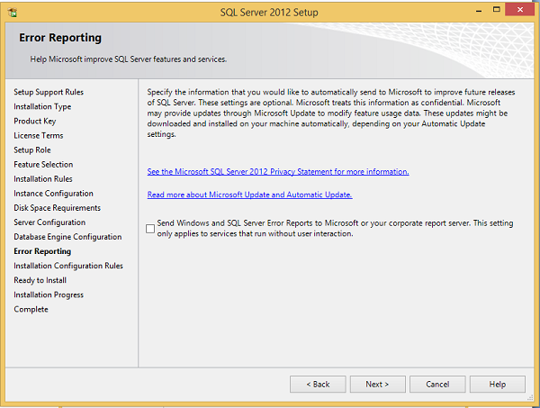
Step 19 − Click Next on the above screen.
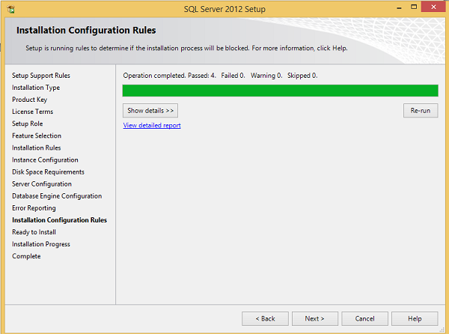
Step 20 − Click Next on the above screen to the get the following screen.
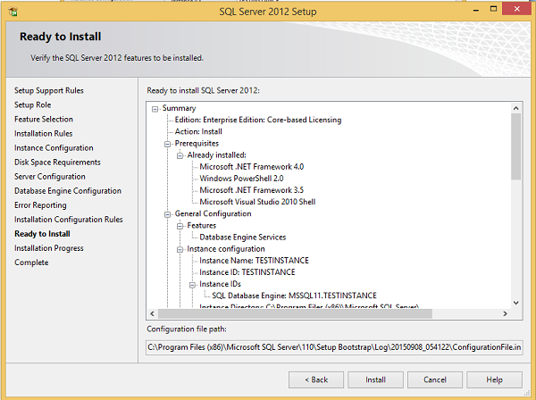
Step 21 − Make sure to check the above selection correctly and click Install.
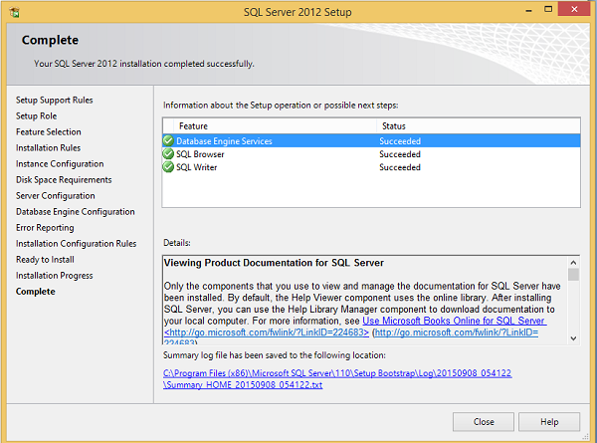
Installation is successful as shown in the above screen. Click Close to finish.

SQL Server Databases
Database is a collection of objects such as table, view, stored procedure, function, trigger, etc.
In MS SQL Server, two types of databases are available.
- System databases
- User Databases

System Databases
System databases are created automatically when we install MS SQL Server. Following is a list of system databases −
- Master
- Model
- MSDB
- Tempdb
- Resource (Introduced in 2005 version)
- Distribution (It’s for Replication feature only)
Master Database
- Master Database contains information about SQL server configuration.
- Without Master database, server can’t be started.
- This will store the metadata information about all other objects(Databases,Stored Procedure,Tables,Views,etc.) which is Created in the SQL Server .
- It will contain login information of users.
- If the master database gets corrupted and is not recoverable from the backup, then a user has to again rebuild the master database.
- Therefore, it is always recommended to maintain a current backup of the master database.
- As everything crucial to SQL server is stored in the master database, it cannot be deleted as it is the heart of SQL SERVER.

Model Database
- The model database sets a template for every database that was newly created .
- It serves as a template for the SQL server in order to create a new database.
- When we create a new database, the data present in model database are moved to new database to create its default objects which include tables, stored procedures, etc.
- Primarily, the requirement of model database is not specific to creation of new database only.
- Whenever the SQL server starts, the Tempdb is created by using model database in the form of a template.
- By default, it does not contain any data.

Msdb
- The msdb database is used mainly by the SQL server Management Studio, SQL Server Agent to store system activities like sql server jobs, mail, service broker, maintenance plans, user and system database backup history, Replication information, log shipping
- We need to take a backup of this database for the proper function of SQL Server Agent Service.

TempDB
- From the name of the database itself, we can identify the purpose of this database.
- It can be accessed by all the users in the SQL Server Instance.
- The tempdb is a temporary location for storing temporary tables(Global and Local) and temporary stored procedure that hold intermediate results during the sorting or query processing and cursors.
- If more temporary objects are created and used storage of tempDB then performance of SQL Server will affect.
- So recommened to move the temdb to the location where sufficient amount of space is there.
- This Database will be created by SQL Server instance when the SQL Server service starts.
- This database is created using model database. we cannot take a backup of temp Database.
Resource Database
- The Resource database is a read-only database that contains all the system objects that are included with SQL Server.
- SQL Server system objects, such as sys.objects, are physically persisted in the Resource database, but they logically appear in the sys schema of every database.
- The Resource database does not contain user data or user metadata.
- The Resource database makes upgrading to a new version of SQL Server an easier and faster procedure.
- In earlier versions of SQL Server, upgrading required dropping and creating system objects.
- Because the Resource database file contains all system objects, an upgrade is now accomplished simply by copying the single Resource database file to the local server.
Distribution Database
- The distribution database stores metadata and history data for all types of replication, and transactions for transactional replication.

